# **Project : SFPD-Crime**

### Date: 2020-04-11 ---- Team Members : Group 4: Chandler, Daniel, Elena, Joe O., Jorge, Nell

* **Topic**:
  + What story does Crime in San Francisco over (time period tbd) tell us?
* **Data Set**:
  + Google Cloud BigQuery Public Data
    - Dataset ID: bigquery-public-data:san_francisco_sfpd_incidents
    - Created: Apr 11, 2017, 9:04:03 AM
    - Data location: US
* **Inspiration**:
  + Curiosity, San Francisco, Crime
* **Ideal Visuals**:
  + Latitude and Longitude coordinates will allow Mapping visuals. Various Crime Categories or Timestamp could possibly act as a filter.
  + Curiosity of how crime trended year of year
  + Crime category by popularity
  + Map using layers using categories
* **Why this topic you ask?**
  + We found a rich data source that can be isolated by specific regions within San Francisco, that includes categorical attributes. Coordinates are also included which will be utilized for visual mapping. This will be the platform that we use to build our story of “What does Crime in San Francisco tell us, over a tbd time period (or by category). Will a certain part of town be “safer” than another? What are some crimes that are happening in certain areas? Which part of town seems safer to live in? Some of the questions we will find and reasons why we wanted to pick this topic. We will have a dropdown menu, by category, that will dynamically update the map. We will use d3.js code to interact with the dataset and plan to use Plotly for map and chart creation. Ultimately the data can reflect how crime has changed year over year in the San Francisco area.
* **Data Set(s) Link and Screenshots of Metadata.**
  + Link: <https://console.cloud.google.com/bigquery?project=omniscientify-web&folder=&organizationId=&p=bigquery-public-data&d=san_francisco_sfpd_incidents&page=dataset>

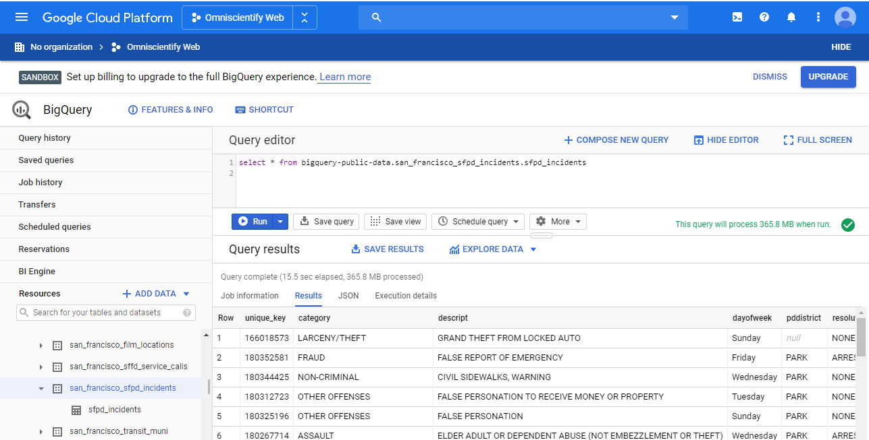

* **Primary link to the GitHub Repo that will be used for the project:** 
  + <https://github.com/joeyorona/SFPD-Crime-Category>